Page no. 47
Assignment: SQL Commands with Usage and Output
1. Creating a Table :
This command is used to create a table named Employees with columns ID, Name, Role, Salary, Joining_Date, and Company. Each column is defined with its data type and constraints.
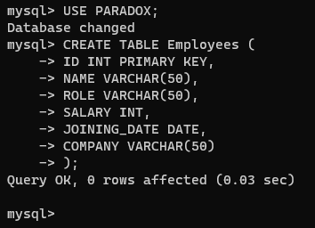
2. Insert Records :
This command inserts new records into the Employees table with specific values for each column.
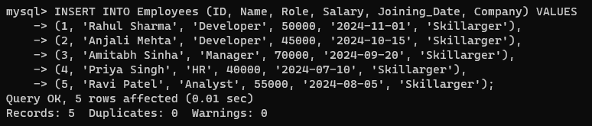
3. Select All Records :
This command retrieves all rows and columns from the Employees table, displaying the complete dataset.
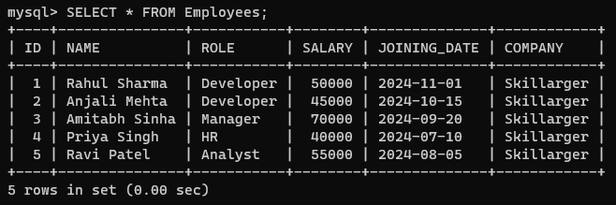

Page no. 48
4. Select Specific Columns :
This command retrieves only the Name and Role columns from all employees, ignoring the rest of the data.
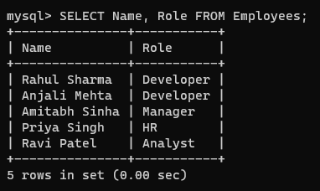
5. Filter by Salary :
This command retrieves records of employees whose salaries are greater than 50,000.
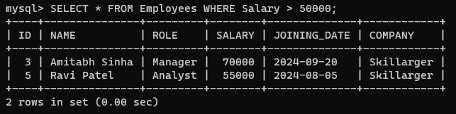
6. Update a Record :
This command updates the salary of the employee with ID = 2 to 60,000.
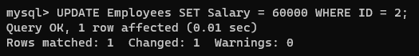
7. Delete a Record :
This command deletes the record of the employee with ID = 4.
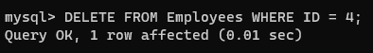

Page no. 49
8. Count Total Records :
This command counts the total number of rows (records) in the Employees table.
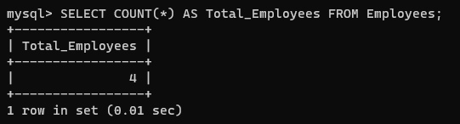
9. Sort Records :
This command sorts the rows of the Employees table in descending order based on the Salary column.
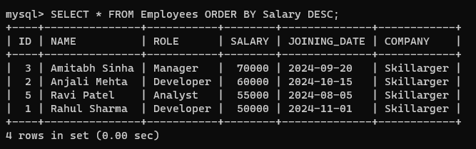
10. Find Maximum Salary :
This command retrieves the maximum salary value from the Employees table.
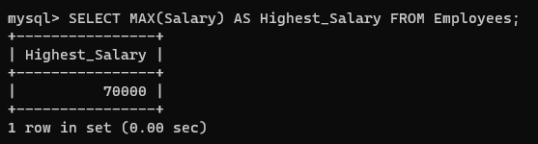
11. Group by Role :
This command groups the data by the Role column and counts the number of employees in each role.
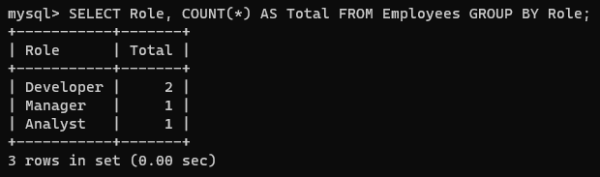
Page no. 50
12. Drop the Table :
This command deletes the Employees table and all its data permanently from the database.
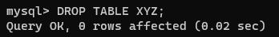
13. Add a New Column :
This command adds a new column Email to the Employees table.
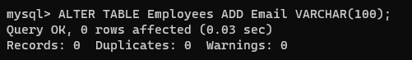
14. Update Email Addresses :
This command generates email addresses for employees by combining their names and the company domain.
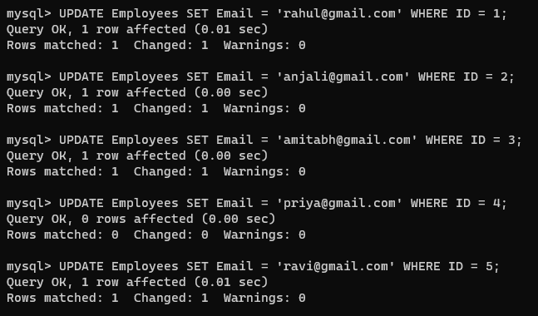
15. Select Records with Email Column :
This command retrieves the ID, Name, and Email columns from the Employees table. 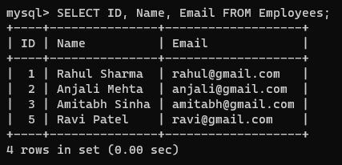
Page no. 51
16. Filter by Joining Date :
This command retrieves records of employees who joined after September 1, 2024.
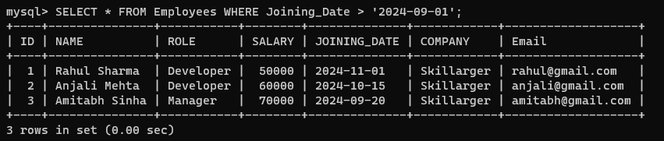
17. Rename Column :
This command renames the column Email to Contact_Email in the Employees table.
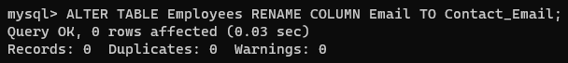
18. Add a New Employee :
This command inserts a new employee record into the Employees table.
19. Show Updated Table :
This command displays all records from the updated Employees table, including the newly added employee.
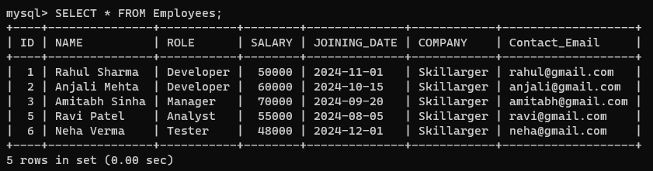

Page no. 52
20. Create a View :
This command creates a view named HighEarners to display employees whose salary is greater than 50,000.
21. Display View Data :
This command retrieves all records from the HighEarners view.
